**AMAZON CLOUDWATCH**

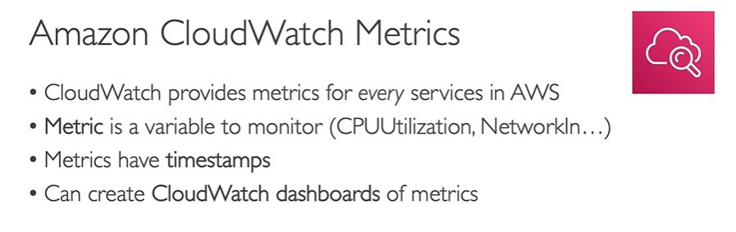

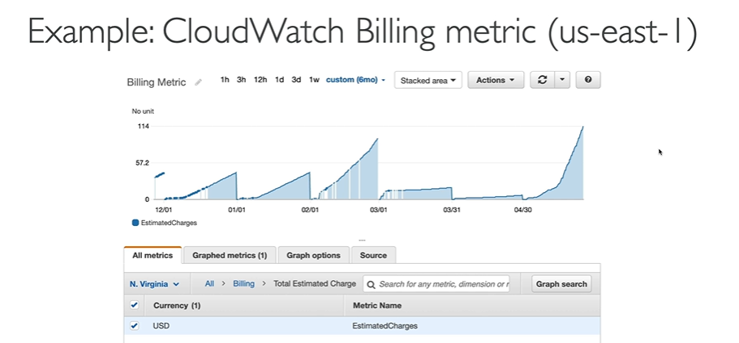

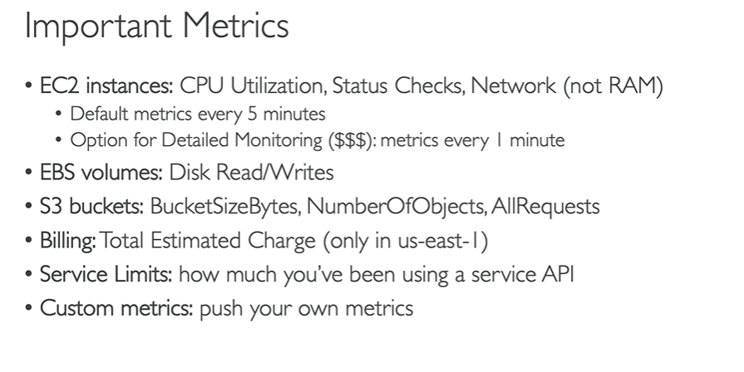

**AMAZON CLOUDWATCH ALARMS**

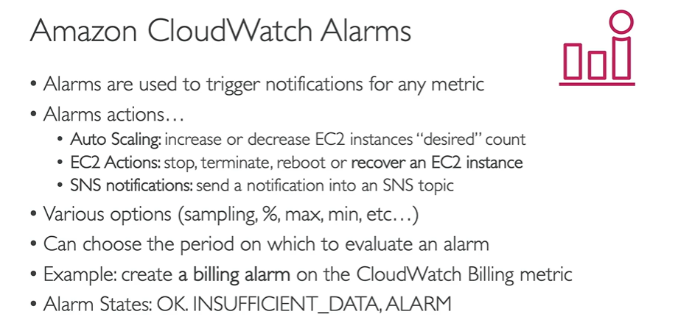

**AMAZON CLOUDWATCH LOGS**

As the name suggests, CloudWatch logs are used to collect log files.

